The Data Extraction Tool User’s Manual

Name: Simon He

Email: simon.dl.he@philips.com

This software tool is for data extraction from PCK lighting fixtures test station. It can help us to gather the data from massive discrete reports into an excel file for analyze.

1. Double click the icon of the tool: DigDataV2.exe



2. The software main window as below, follow the step to select correct items.

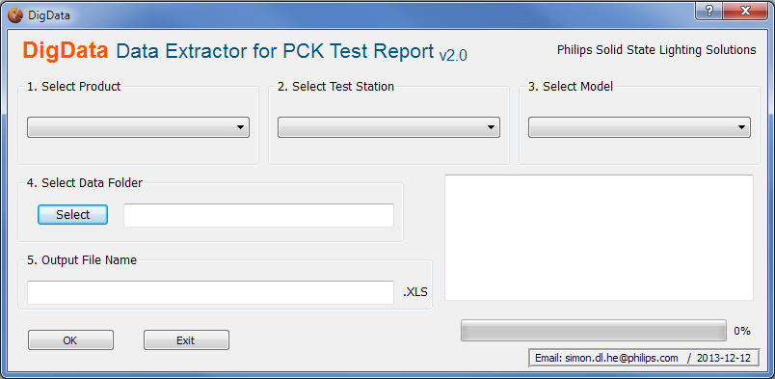

For example, if you want to extract the Reach Compact Power Test data, then you follow below steps:

1. Select Product Name

2. Select Station Name

3. Select Model Name ( If there only one model, then the name will be “ALL” )

4. Select the target folder which store the csv files (Test result files which generate from test software)

5. Enter the output file name

6. Click “OK” Button

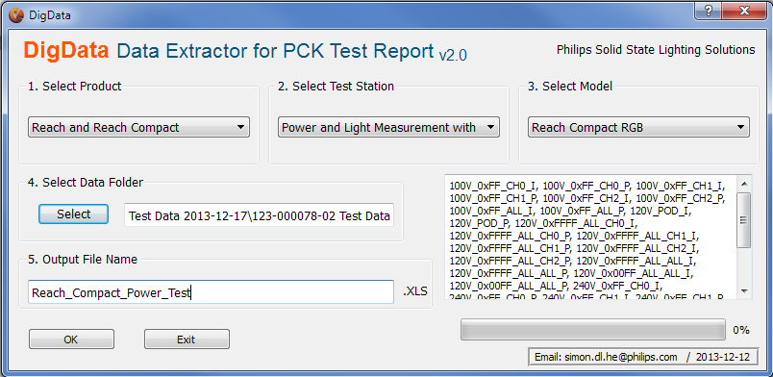

3. After the progress bar finished, the software will generate an excel file which contains the test data you want.

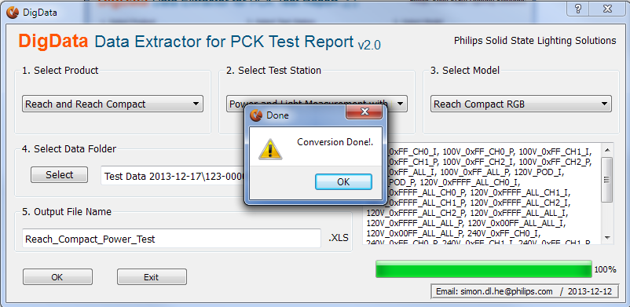

4. Open the output file for your analyze. The fail unit and fail item will display RED.

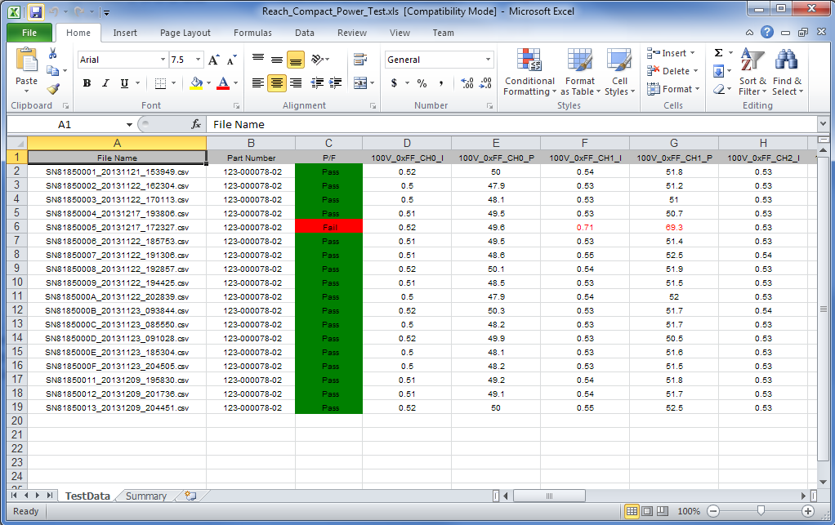

Appendix 1: The structure of Config.v

The format of generated test report is determined by the config.xml file. This file specifies the Product name, Station name, and Fixture type and cell info of the test result.

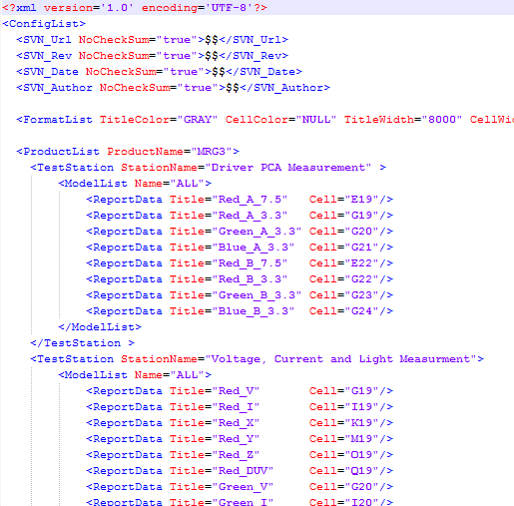

If you want to add a new product, then you have to follow the XML data structure to add the information.

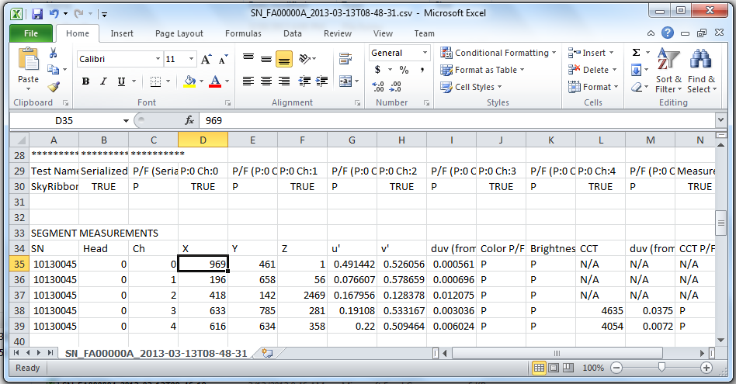

Appendix 2: List of current data supported

|  |  |  |  |
| --- | --- | --- | --- |
| No. | Product Name | Station Name |  |
| 1 | ICOLOR_MRG3 | DRIVER_PCA_FTE |  |
|  |  | LIGHT_MEASUREMENT |  |
| 2 | UGRAZE | POWER_PCA_FTE |  |
|  |  | LIGHT_MEASUREMENT |  |
| 3 | PLC_RECV | PDS_TEST_ENGINE |  |
| 4 | SKYRIBBON_GRAZE | LIGHT_MEASUREMENT |  |
| 5 | ARCHIPOINT | FTE |  |
|  | Reach and Reach Compact | FTE Power Tray |  |
|  |  | Power and Light Measurement with DEpro |  |
| 6 | Dim 2 Warm | FTE and Light measurement |  |